**CSA1195 OBJECT ORIENTED ANALYSIS AND DESIGN**

**DAY 1 LAB PRACTICAL : 08.08.2023**

**NAME : P.GUNADEESH REDDY**

**REGISTER NUMBER : 192111198**

1.Develop a system using UML for Passport Management System; it should verify the passport details of the applicant by the central computer. The details regarding the passport will be provided to the central computer and the computer will verify the details of the applicant and provide approval to the office. Then the passport will issue from the office to the applicant.

**USE CASE DIAGRAM FOR PASSPORT MANAGEMENT SYSTEM:**

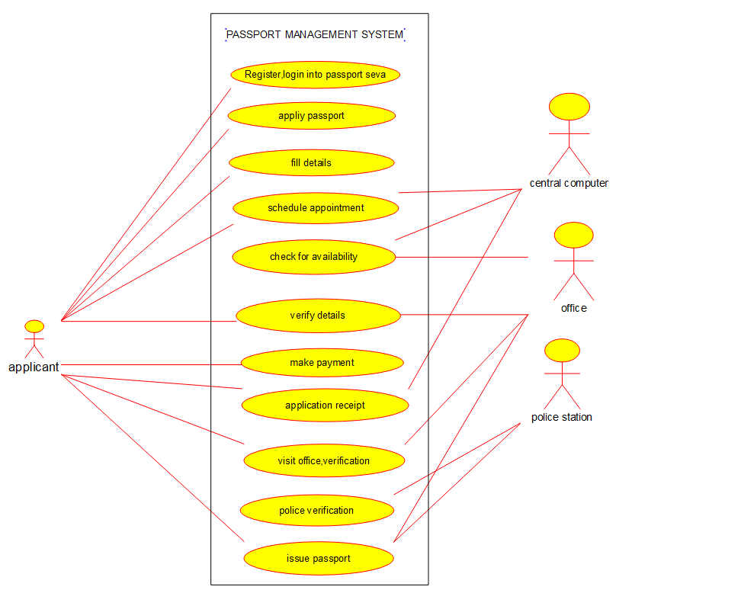

**CLASS DIAGRAM FOR PASSPORT MANAGEMENT SYSTEM:**

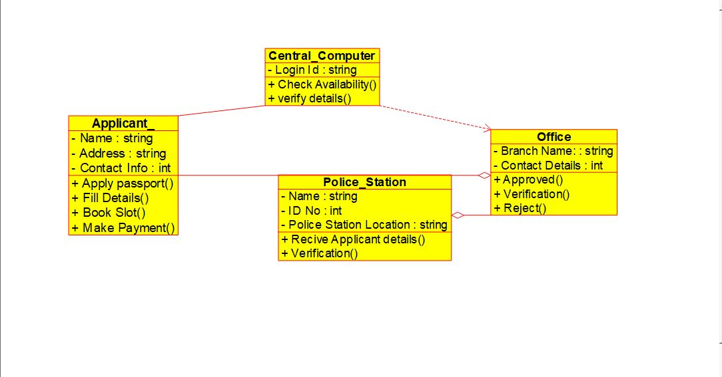

**ACTIVITY DIAGRAM FOR PASSPORT MANAGEMENT SYSTEM:**

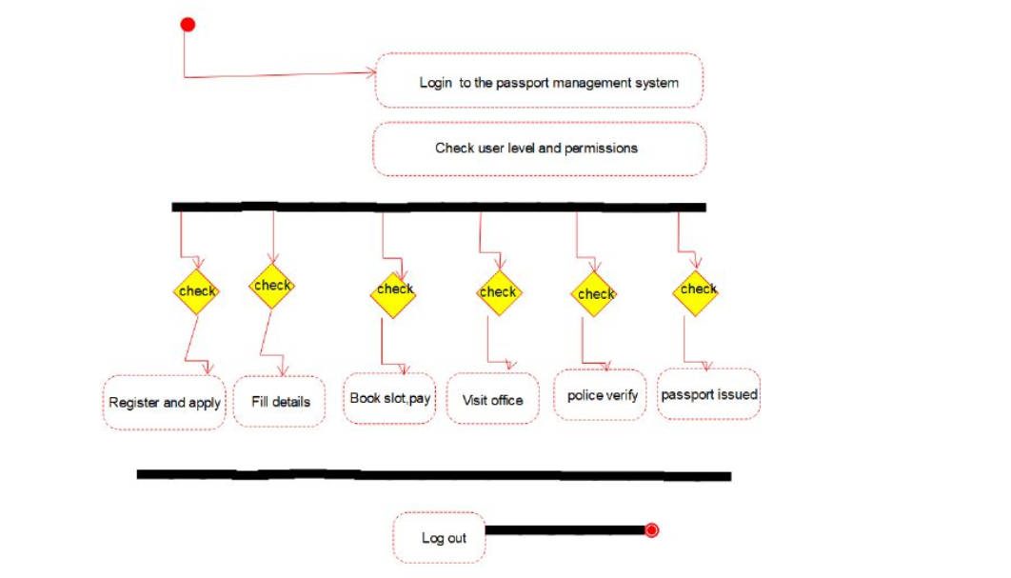

1. Develop a system using UML for implementing the Book Bank process. It should verify the details of the student by the central computer. The details regarding the student will be provided to the central computer through the administrator in the book bank and the computer will verify the details of the student and provide approval to the office. Then the books that are needed by the student will issue from the office to him.

**USE CASE DIAGRAM FOR BOOK BANK MANAGEMENT SYSTEM:**

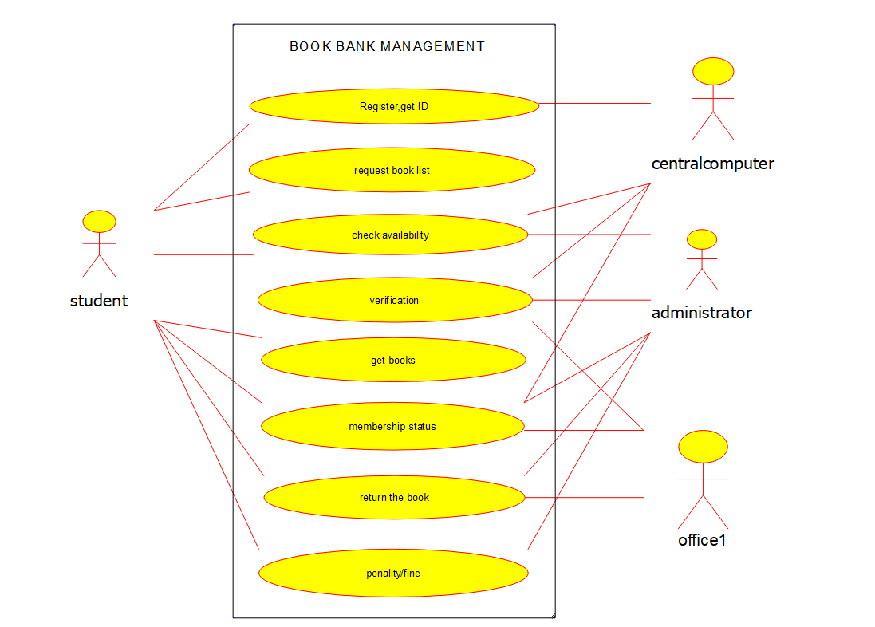

**CLASS DIAGRAM FOR BOOK BANK MANAGEMENT SYSTEM:**

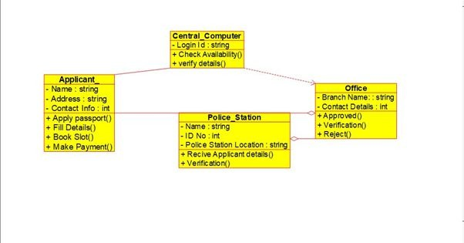

**ACTIVITY DIAGRAM FOR BOOK BANK MANAGEMENT SYSTEM:** 